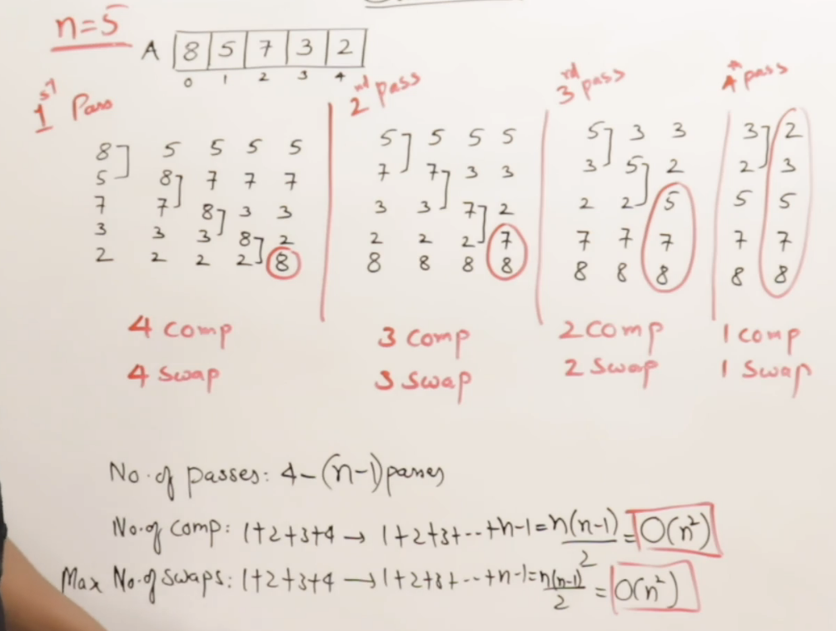

For 5 elements, there are 4 passes. So for n elements there are n-1 passes.

# **Adaptive Property**

In a sorted list, If we perform sorting then the swapping should not take place.

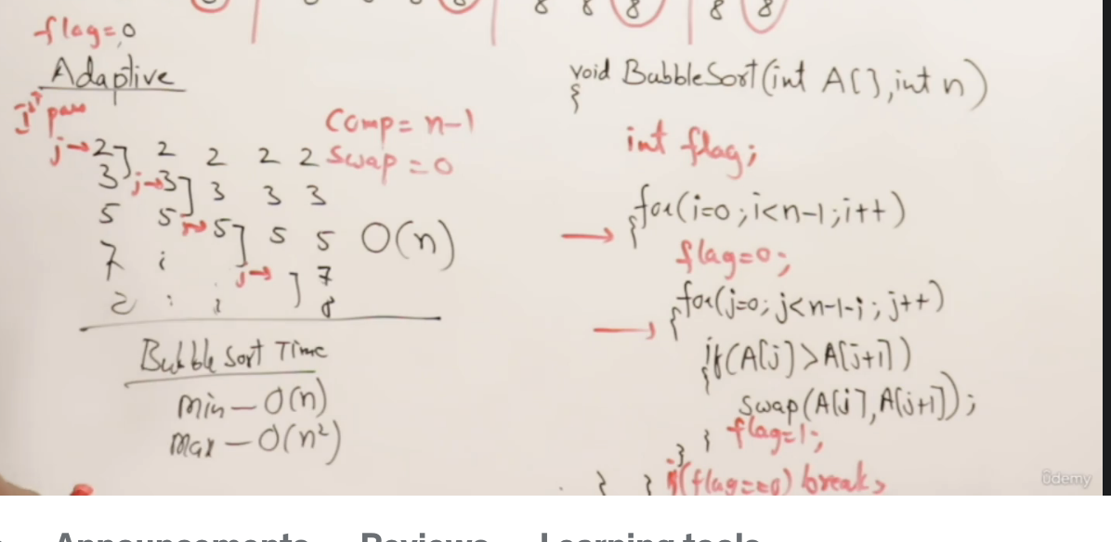

By nature bubble sort is not adaptive, we made Bubble sort as adaptive.

# **Stable Property**

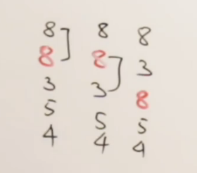 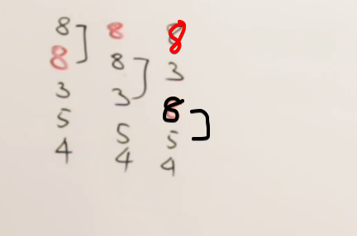

Only 2nd 8 is swapped, 1st 8 remains there it-self. This will not happen

By nature bubble sort preserves the order and it is stable.

# **Key-Points**

1st pass 🡪 will get 1 largest element  
2nd pass 🡪 will get 2 largest elements

..

Kth pass 🡪 will get k-largest elements

🡪 After every pass, will get a larger element at the end.